No. 004/23

6th January 2023

TO: ALL POSTAL BRANCHES

Dear Colleague,

ROYAL MAIL GROUP DISPUTES UPDATE – REFRESHED TALKS

We are writing to update you on a number of developments in our disputes with the Royal Mail Group.

Following discussions over the last few days, we have now agreed with the company to refresh our talks and engage in intensive negotiations from the 9th to 20th January.

The above is confirmed in an exchange of correspondence which is also attached to this LTB.

Branches, Reps and members will see that Royal Mail Group has made a number of significant moves towards the union, covering the following:

- RMG has agreed to immediately remove the agency staff used to cover the Christmas peak and strike action.
- RMG has accepted that the CWU will engage members in our campaign to win a re-ballot, while negotiations continue
- RMG has reinstated the industrial relations framework for all revision activity. This is a significant development which gives us the ability to negotiate at local level, rather than managerial imposition of change. However we must be clear, as stated in our letter to Royal Mail, the outstanding issue of revision guidelines needing to be agreed, remains a major concern and may be a barrier to progress. This will be discussed as a priority on the first day of our talks.
- RMG has committed to reviewing all cases put forward by the CWU that have arisen from the dispute relating to suspensions, conduct charges and dismissals. The CWU has made clear that we will never accept these unfair attacks on our members and representatives and a resolution to this must be found over the next couple of weeks.

While recognising that some progress has been made, given the unacceptable actions of the company over the last few months, we do not take anything for granted and we know there are major differences between us on a raft of key issues.

Notwithstanding the above, the Postal Executive believe that now is the right time to try and change the dynamic of the dispute by pausing strike action and prioritising refreshed talks and the need to return another massive turnout and Yes vote in our re-ballot campaign.

During this period we have also secured a number of activities to raise the profile of our disputes, as follows:

- 10th January- Westminster Hall debate on Postal Services (Post Office and Royal Mail)
- 12th January- Westminster Hall debate on Royal Mail and the Future of the Universal Service Obligation
- 17th January- The CWU will be giving evidence to the Business, Energy and Industrial Strategy Parliamentary Select Committee, which has been called to discuss the mismanagement of Royal Mail and the future of the USO and our dispute
- 23rd January- we will be meeting with major Royal Mail shareholders to explain our concerns about the dispute and the future of the company.

We know this has been an extremely difficult dispute but there is no doubt that the strength of our membership over the last few months has delivered progress. We will discuss this progress and other developments on a live Facebook session on Tuesday 10th January at 7pm.

In the meantime, it is of paramount importance that the whole union re-engages our members in a campaign to win the second ballot and this will be pivotal to the successful outcome of our disputes.

We look forward to meeting branches and representatives at the National Briefing on the 10th January and we would ask that you convey the attached membership communication to all workplaces.

Any enquiries on the above should be addressed to the General Secretary/Acting Deputy General Secretary (Postal) at jdunn@cwu.org/fkelk@cwu.org.

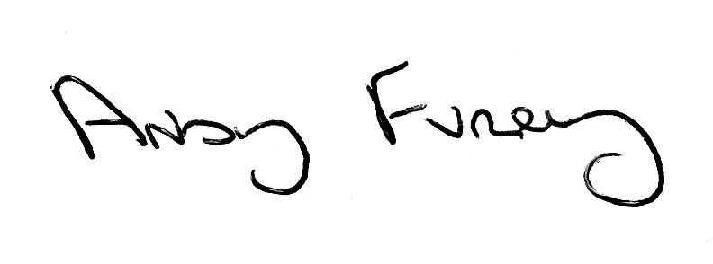
Yours sincerely

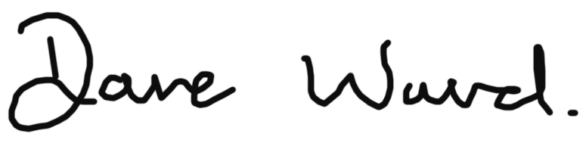

Dave Ward Andy Furey
General Secretary Acting Deputy General Secretary (Postal)

