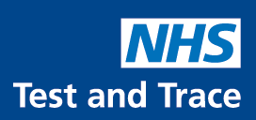
CORONAVIRUS / COVID-19: LATERAL FLOW DEVICE TESTING
1 in 3 people who have Covid-19 don’t have any symptoms and can spread the virus without knowing it.

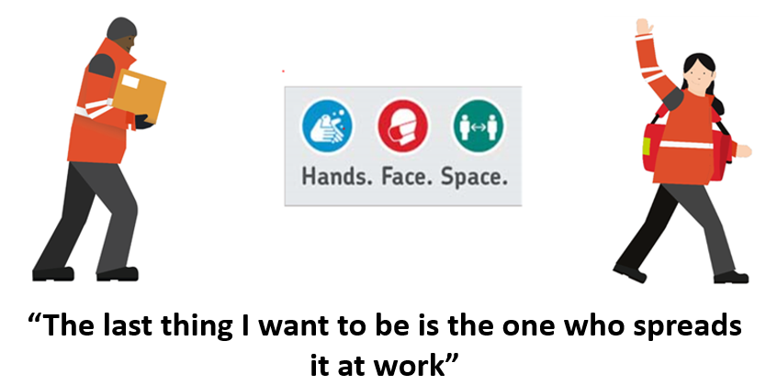

We want all employees to participate and to test themselves even if they don’t have any symptoms and to test regularly.
Line managers will provide staff with free home testing packs.
Royal Mail, Parcelforce and the Unions want your full support and participation with regular LFD testing.

have Covid-19 don’t have symptoms
Get free rapid tests & test regularly
Testing even if you don’t have symptoms

