Feb 2017

Dear Colleague,

Royal Mail Proposal to close the Defined Benefit Pension Scheme

As you will know from communications you will have received from both Royal Mail and the CWU, Royal Mail have entered a 60-day consultation period to close the Defined Benefit Pension Scheme.

These proposals will leave many in financial hardship during retirement.

The CWU Nationally want to enter meaningful negations with Royal Mail to secure a healthy pension for all.

We need to send a strong message to Royal Mail that we are not willing to accept the term of the current proposals. We’re asking you to complete the enclosed letter with your signature, pay number and date it. You can then use the envelope provided and send the letter, FREEPOST to Royal Mail.

If you have any enquiries regarding this don’t hesitate to contact me on the details above.

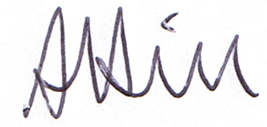Yours Sincerely

Amanda Hill
Branch Secretary

