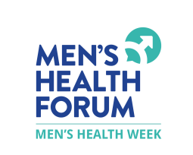SMOKING FAQS
We all know smoking isn't good for us but what can you do about it.
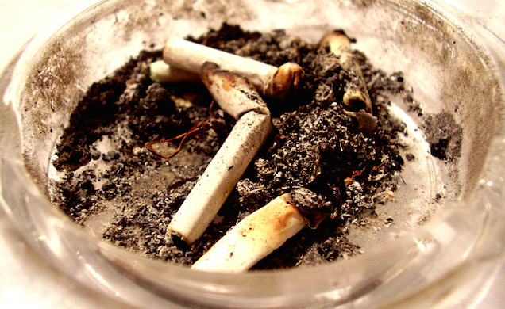

Why do I enjoy smoking?
Nicotine, the addictive drug in tobacco, provides instant but very short-lived stimulation to the nervous system, reducing tiredness and improving concentration.
When you're nervous, smoking also gives you something to do with your hands and the deep breathing involved is relaxing. For over a century most popular and youth cultures have regarded smoking as cool. As a result it helps some people feel part of those cultures, and therefore better about themselves.
Unfortunately, smoking does a lot of damage too.

What are the advantages of giving up?
You probably know these already, but it boils down to this: one in two smokers will be killed by their habit. This is because smoking causes:
- one-third of all cancer deaths
- four out of five lung cancer deaths
- four out of five deaths from bronchitis and emphysema
- one in four deaths from heart disease
No part of the body is unaffected. Two thousand arms and legs are amputated every year in the UK as a direct result of smoking.
Tobacco is a poison. The tar which causes so much of the damage contains arsenic, cyanide, formaldehyde and benzene (yum yum). Tobacco smoke also contains the killer compound carbon monoxide, which reduces oxygen in the blood and thus the body's performance.
Stopping smoking immediately cuts your risk of all the above, especially if you give up before you are thirty. Stopping smoking will almost certainly increase the length of your life and you will definitely:
- feel fitter and perform better (including in the bedroom, because smoking even reduces the quality and, because of reduced blood flow, the size of your erections and damages your sperm);
- look and smell better;
- be able to taste good food and smell sweet smells again;
- be richer — a 20-a-day cigarette habit costs well over £1,000 a year;
- be doing everyone a favour — if you have kids, you will no longer be a health hazard to them and the rest of the population. The smoking information organisation ASH (Action on Smoking and Health) estimates that several hundred people die every year from breathing others' cigarette smoke.

What are the alternatives to giving up?
None, really.
- Cutting down doesn't work, because although nicotine is highly addictive, its effects last only a few moments. Cutting down puts you in a constant battle with your addiction which it will eventually win if you don't stop completely.
- Switching to lower tar cigarettes is also of little benefit, as the evidence suggests that smokers of low tar cigarettes simply inhale more deeply or cover up the filter holes with their fingers to get the same hit. As a result some highly dangerous forms of lung cancer actually appear to be higher in smokers of low tar cigarettes.
If you aren't ready to give up yet, leave as long a stub as possible and try setting short-term targets for yourself which limit your smoking — only smoking on the hour, for example.

In practice, how do I give up?
- Some people like to choose a date and psyche themselves up to it. Others prefer to stop dead. Whatever you do, most people agree it is better to stop completely than cut down.
- Removing the reminders of smoking, such as ash-trays and lighters, might help. So will avoiding places or situations where you're tempted to smoke (e.g. pubs or restaurants). Clean the house and launder your clothes to get rid of the smell. Avoid other smokers. The truth is that even your best friends, if they are smokers, will not want you to succeed where they have failed. (The vast majority of smokers would quit if they could.)
- Try to choose a time which will work for you — when you've got plenty of other things to do and not too much stress. During a holiday can be good. Moving job or going to college can also work if it's not too stressful. Present yourself in your new environment as a non-smoker and then nobody will offer you a fag or ask you how you're coping without them.
- Make a list of the reasons you are giving up. Pin them up, say them, remind yourself of them frequently. Put the money saved to one side and treat yourself with it every month.

What can help?
Your determination. Ultimately, you will only succeed if you are really ready to quit. However, all the following may help maintain your resolve:
- Nicotine replacements such as gum, patches and inhalers are available, some over the counter from your pharmacist. Nicotine replacement therapy is also available on the NHS through GPs. A review of all the research found that nicotine replacement therapy can double the chances of quitting. There's no evidence that one nicotine product is more effective than another, but gum will ease the craving most quickly (good if you are only severely tempted at certain times), while patches provide a steady dose which may be better for the all-day-round smoker.
- Drinking water — drink throughout the day and especially when you're craving.
- Exercise — swimming, jogging, underwater basket-weaving, anything that keeps you busy.
- (Healthy) eating — chew on a carrot rather than chocolate bar.
- Alternative therapies — many ex-smokers will tell you that treatments such as massage, aromatherapy and especially acupuncture helped them quit. If you fancy it, give it a try. You can probably afford it with the money you're saving.
- Medication — the antidepression drug bupropion hydrochloride (trade name Zyban) is now also used to help people quit smoking. Some studies suggest it's more effective than a nicotine patch. It has similar effects on the brain to nicotine, which means there is a small risk of seizure in some people. It can also cause a dry mouth and insomnia and isn't recommended for people with eating disorders. Treatment should start at least a week before you stop smoking, so if you're thinking about this talk to your GP in good time.
- Joining a quitting support group or seeing a smoking cessation counsellor. Research shows that both can make a significant difference to your chances of giving up. Your GP should be able to refer you.

What should I do when I get the urge?
Anything that stops you smoking — within reason and in the short term, anyway. Practise the Five Ds:
- Take DEEP breaths. Slowly inhale and exhale (rather like the first drag of a fag)
- DRINK some water
- DO something else — shopping, a walk, call a mate
- DIP into your alternatives — whether it's a carrot, nicotine gum or a boiled sweet
- and, most of all, DELAY reaching for a cigarette. The body will readjust so the worst of the craving only lasts a short while

Who else can help?
- Get help right now from the NHS to stop smoking

MAIN IMAGE: Ashtray by Mark Chatterley licensed under CC BY-SA 2.0
We don't currently post comments online but are always keen to hear yourfeedback.
Date published 02/04/14
Date of last review 02/04/14
Date of next review 02/04/16

References
- NICE Guidance - Smoking Cessation
- Map of Medicine - Smoking Cessation Pathways
- Cochrane Review - Nicotine Replacement Therapy
- NHS - Quit Smoking

